***HEARING TESTIMONY – April 27, 2021***

**Charles County Maryland Public Budget Hearing**

**Budget Proposals for FY22**

*Good evening. My name is Sandy Washington, I am the Executive Director of Lifestyles of Maryland Foundation, Inc*. *We would like to thank you for taking the time to read this correspondence and enter it into the official meeting records, regarding the proposed FY22 budget.*

*Every year day in and day out non-profits in our community work to address the needs of county residents. From those who are seeking services for the elderly, homeless, individuals with differing abilities to those seeking help or services for their pets. No matter the request, there is a non-profit usually at the ready prepared to meet these needs. For over a year during a pandemic we have strived and survived some of the worse conditions one could think of. Yet many of us are still standing, merely because of the compassion and desire to serve our community. We have continued to do this with minimal funds from the County. While all are appreciative of the CARES ACT funds that were provided, we must see an increase in the budgeted amount to our non-profits.*

*We are requesting that the County reconsider the allocation to the non-profits in our community and increase the line item to the one million dollars requested by the Charitable Trust. The services and commitment of these organizations are far more than this request. The Commissioners must recognize the value of our non-profits and provide the support needed.*

*We can truly work together to support the residents of Charles County.*

*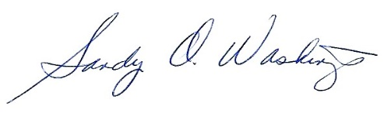Thank you.*

*Sandy O. Washington*

Executive Director

*Phone: 301-609-9900 ext. 215*

*Address: 101 Catalpa Drive*

*La Plata, MD 20646*